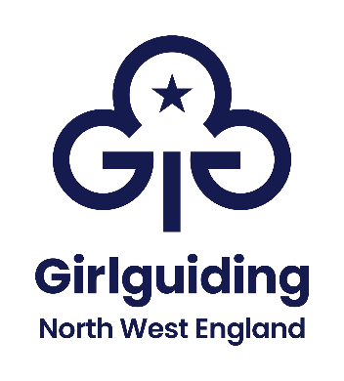
Equality and diversity monitoring form
Girlguiding North West England wants to meet the aims and commitments set out in our equality policy. This includes not discriminating under the Equality Act 2010.
Please complete this form to help us understand the diversity of our job applicants.
Completing this form is voluntary. The information provided will be kept confidential. The information is going to be used to help us understand the diversity of our organisation.
None of the information you provide will be linked to your application.
If you have any questions about the form contact louisa.wright@girlguidingnwe.org.uk
Please return the completed form to louisa.wright@girlguidingnwe.org.uk

Age
What is your age?
☐ 19 or under
☐ 20 to 29
☐ 30 to 39
☐ 40 to 49
☐ 50 to 59
☐ 60 to 69
☐ 70+
☐ Prefer not to say

Disability
Do you have a disability, impairment or health condition which affects your day-to-day activities?
☐ Yes
☐ No
☐ Prefer not to say
The information in this form is for monitoring purposes only. If you believe you need a reasonable adjustment, then please discuss this with [your manager/ the manager running the recruitment process].

Ethnicity
What is your ethnicity?
This may be different to your nationality, place of birth or citizenship.

Asian or Asian British
☐ Asian British
☐ Bangladeshi
☐ Chinese
☐ Indian
☐ Pakistani
☐ Another Asian background, please say what:Click or tap here to enter text.
☐ Prefer not to say

Black, African, Caribbean or Black British
☐ African
☐ Black British
☐ Caribbean
☐ Another Black, African or Caribbean background, please say what:Click or tap here to enter text.
☐ Prefer not to say

Mixed or Multiple ethnic groups
☐ Asian and White
☐ Black African and White
☐ Black Caribbean and White
☐ Another Mixed or Multiple ethnic group, please say what:Click or tap here to enter text.
☐ Prefer not to say

White
☐ English
☐ Gypsy or Irish Traveller
☐ Irish
☐ Northern Irish
☐ Scottish
☐ Welsh
☐ Other European
☐ Another White background, please say what:Click or tap here to enter text.
☐ Prefer not to say

Another ethnic group
☐ Arab
☐ Another ethnic group, please say what:Click or tap here to enter text.
☐ Prefer not to say

Religion or belief
What is your religion or belief?
☐ No religion or belief
☐ Buddhist
☐ Christian
☐ Hindu
☐ Jewish
☐ Muslim
☐ Sikh
☐ Another religion or belief, please say which:Click or tap here to enter text.
☐ Prefer not to say

Sex
What is your sex?
☐ Female
☐ Male
☐ Prefer to self-describe, please say how:Click or tap here to enter text.
☐ Prefer not to say

Gender reassignment
Is the gender you identify with the same as your sex recorded at birth?
☐ Yes
☐ No
☐ Prefer not to say

Sexual orientation
What is your sexual orientation?
☐ Asexual
☐ Bisexual
☐ Gay
☐ Heterosexual
☐ Lesbian
☐ Pansexual
☐ Questioning
☐ Prefer to self-describe, please say how:Click or tap here to enter text.
☐ Prefer not to say

